2.Scenario: You are a data analyst working for a company that sells products online. You have been tasked with analyzing the sales data for the past month. The data is stored in a NumPy array.

Question: How would you find the average price of all the products sold in the past month? Assume 3x3 matrix with each row representing the sales for a different product

Code:

mport numpy as np

import pandas as pd

df = pd.read_csv(r"C:\Users\jampa\OneDrive\文档\sales_data.csv", index_col=0)

sales_data = df.to_numpy()

average_price = np.mean(sales_data)

print(f"Average price of all products sold: {average_price:.2f}")

output:

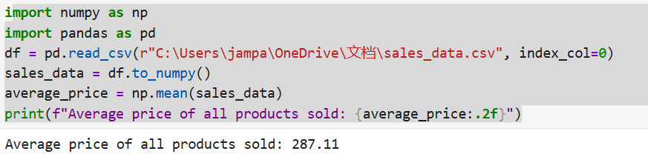

Dataset:

Sale_1 Sale_2 Sale_3

Product_A 428 397 202

Product_B 353 411 155

Product_C 139 366 133